The United States Opioid Epidemic: Data and Visualizations

Team Members:

· *Lin Fu*

· *Rashmi Ray*

· *Rene Lizarraga*

· *Virendra Chauhan*

**Abstract**

Opioids are a group of drugs used for pain relief. Lower doses of Opioid can make the patient sleepy, whereas, the higher doses can slow down breathing and heart rate, that can prove to be fatal. When this medication travels through blood and reaches the opioid receptors in our brain cells, the cells release signals that manipulate the perception of pain and enhances the feelings of pleasure. A strong urge to continue this feeling of pleasure often leads to addiction of the drug.

Prescription Opioids are normally safe when taken as prescribed. The same prescription can be misused by an addict. More than 100 lives are estimated to be lost every day in the country due to Opioid overdose. This is a national crisis that is affecting social as well as economic welfare of the nation.

“The Centers for Disease Control and Prevention estimates that the total "economic burden" of prescription opioid misuse alone in the United States is $78.5 billion a year, including the costs of healthcare, lost productivity, addiction treatment, and criminal justice involvement.”[[1](https://www.drugabuse.gov/drugs-abuse/opioids/opioid-overdose-crisis)]

Aware of the severity of the complication, our team decided to analyze the data collected by Center for Disease Control [CDC]. We are looking forward to develop an application that will provide the visual statistics of the epidemic across the country.

**Introduction**:

According to the latest report publish in Mar 2018, by Nation Institute of Drug Abuse, more than 115 lives are lost every day nationally [2]. In 1990s, this flood gate opened when around a one in every 3 American was estimated to suffering from chronic pain [3]. The drug companies took this opportunity to push the federal government to expand the use opioids for pain relief. The number of prescriptions nearly tripled from 76 million to 219 million in the period of just 20 years spanning from 1991 to 2011. [3]

“Opioids are a diverse class of moderately strong [painkillers](https://en.wikipedia.org/wiki/Analgesic), including [oxycodone](https://en.wikipedia.org/wiki/Oxycodone) (commonly sold under the trade names [OxyContin](https://en.wikipedia.org/wiki/OxyContin) and [Percocet](https://en.wikipedia.org/wiki/Oxycodone/paracetamol)), [hydrocodone](https://en.wikipedia.org/wiki/Hydrocodone) ([Vicodin](https://en.wikipedia.org/wiki/Hydrocodone/paracetamol), [Norco](https://en.wikipedia.org/wiki/Hydrocodone/paracetamol)), and a very strong painkiller, [fentanyl](https://en.wikipedia.org/wiki/Fentanyl), which is synthesized to resemble other [opiates](https://en.wikipedia.org/wiki/Opiate) such as [opium](https://en.wikipedia.org/wiki/Opium)-derived [morphine](https://en.wikipedia.org/wiki/Morphine) and [heroin](https://en.wikipedia.org/wiki/Heroin)[3]”

The US health care system has been playing an invisible yet absolutely avoidable role in causing this outbreak. According to an article publish Oct 2017, Professor Judith Feinberg from the West Virginia University School of Medicine stated "Most insurance, especially for poor people, won't pay for anything but a pill." [4] He continued on to explain that even if a better solution is available, the insurance companies either mostly don’t cover it or it involves lot of paperwork for preapproval process, thus the patients resort to the prescription pain killers that in most cases leads to addictions. A study published 2018 has found that 75% of opioid users were introduced to the drug though a legitimate prescription [3]

**Data Sourcing:**

Two data sources were used for this analysis focusing on opioid use as a prescription medication and its impact from 2010 to 2016.

In the United States, the Center for Disease Control and Prevention (CDC) is the leading public health institute that not only protects public health, it also conducts in depth research to facilitate solution for better control of diseases and epidemics. The organization has a major data collection system in place to support its research and analysis the national trend. The team has used the drug overdose data that is available publicly from the organization’s website. This dataset is used primarily analyze drug overdose losses against opioid overdose and prescriptions [5]. The dataset is available in the project team’s github repo [7]

The second dataset used is selected from

Kaiser Family Foundation’s [KFF] website. KFF is a US based non-profit organization that focuses on major health care issues. The organization claims itself a highly credible source of healthcare data [8]. The team has sourced the dataset from KFF to analysis the opioid related loses across 50states, gender, races from 2010 to 2016. This dataset is also available in the team’s git repository [9]

The dataset description is also provided in the same project repository [10]

**Statistical Analysis**

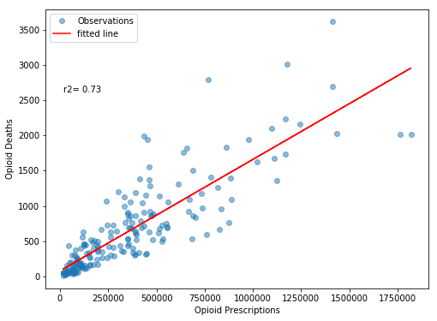

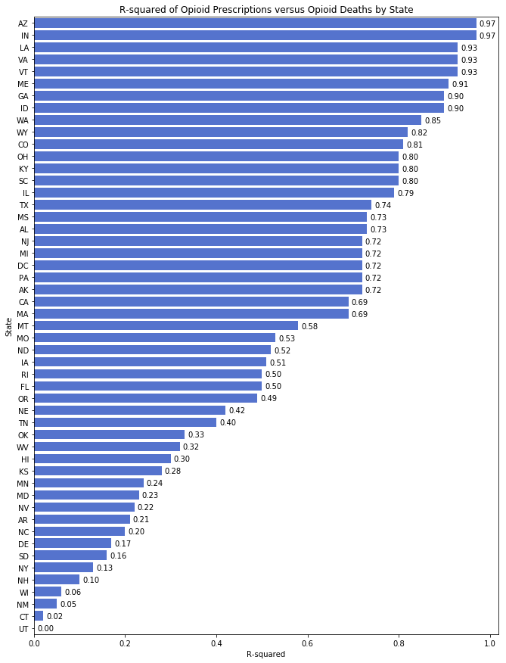

**Tidy Data**

**Initial Analysis**

**Detail Analysis**

**Inferences**

**Conclusion**

**References**

1. <https://www.drugabuse.gov/drugs-abuse/opioids/opioid-overdose-crisis>
2. <https://www.drugabuse.gov/drugs-abuse/opioids/opioid-overdose-crisis>
3. <https://en.wikipedia.org/wiki/Opioid_epidemic>
4. <https://www.bbc.com/news/world-us-canada-41701718>
5. <https://www.cdc.gov/nchs/nvss/vsrr/drug-overdose-data.htm>
6. <https://www.kff.org/state-category/health-status/opioids/>
7. <https://raw.githubusercontent.com/rashray/Opiod-Epidemic-Project/master/data/State_Drug_Utilization_Data_2017-2013%20Opioids.csv>
8. <https://en.wikipedia.org/wiki/Kaiser_Family_Foundation#cite_note-aboutKFF-2>
9. <https://github.com/rashray/Opiod-Epidemic-Project/blob/master/data/Final_OpiodData2010_2016.csv>
10. https://github.com/rashray/Opiod-Epidemic-Project/blob/master/data/readme.md